# Orientation – Week 0 Coding Assignment

**Points possible:** 70

|  |  |  |
| --- | --- | --- |
| **Category** | **Criteria** | **% of Grade** |
| **Functionality** | Does the code work? | 33.3 |
| **Creativity** | Student solved the problems presented in the assignment using creativity and out of the box thinking. | 33.3 |
| **Completeness** | All requirements of the assignment are complete. | 33.4 |

**Instructions:** For most weeks you will have to complete a coding assignment outlined in a document that looks similar to this one. The Coding Steps section contains the problems you will need to solve. The next two sections require you to submit screenshots of your work. Lastly, you will paste the URL to your GitHub Repository which you will learn more about next week.

**Coding Steps:**

Software development requires working knowledge of the command prompt or terminal on your computer. Navigating the command prompt itself is not coding, but it's a prerequisite for coding. For this assignment complete the following steps:

1. Open a command prompt or terminal window. Mac’s have the Terminal app. Windows has the command prompt and type the following commands.

|  |  |  |
| --- | --- | --- |
| Task | Windows Command | Mac Command |
| Print current directory | cd | pwd |
| List contents of directory | dir | ls |
| Create a new directory | mkdir Promineo | mkdir Promineo |
| Change into that directory | cd Promineo | cd Promineo |
| Print current directory | cd | pwd |
| Create a new directory | mkdir Week0 | mkdir Week0 |
| Change into that directory | cd Week0 | cd Week0 |
| Print current directory | cd | pwd |
| Print hostname | hostname | Hostname |

2. Go to <https://zoom.us/test> and join a test meeting. Follow all the prompts to join the meeting and test your audio and video. Once you have joined the test meeting, click on the green shield icon in the top left corner of the screen, choose **Statistics** on the left hand column, and take a screenshot of that window and post it below.

**Screenshots of Code:**

Ignore this section for Week 0.

**Screenshots of Running Application**

[Insert screenshot(s) of the commands you typed above and the zoom Statistics window here 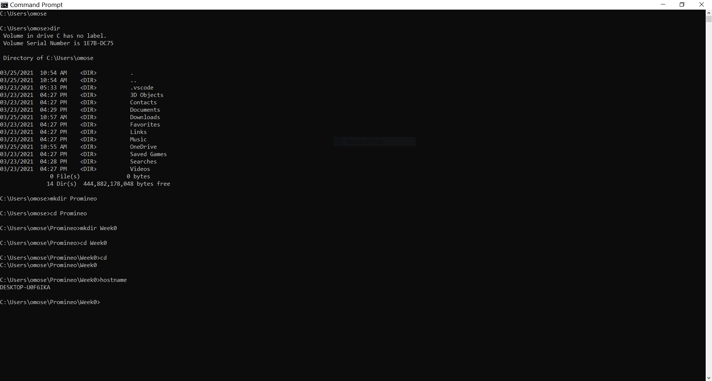

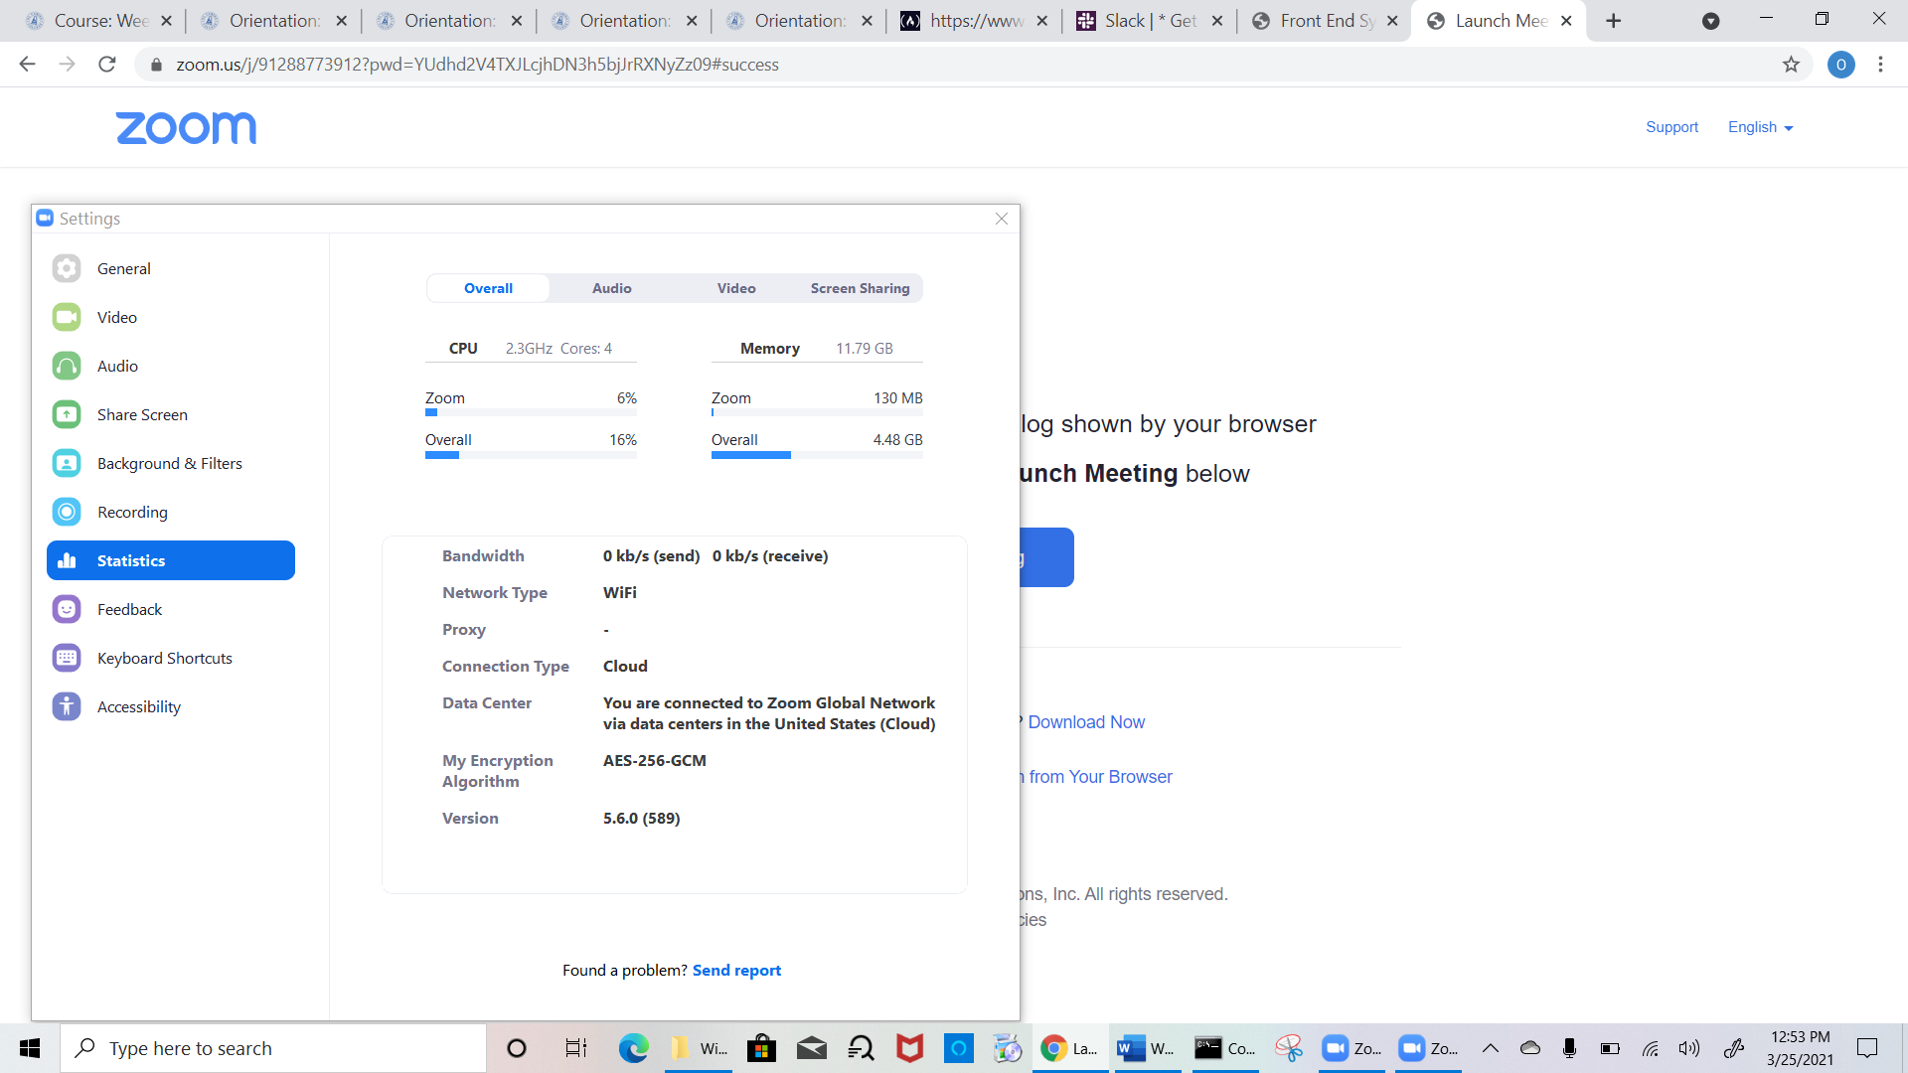

then upload this entire file with the screenshot(s) back to the LMS.   
  
On MacOS, press Command+Shift+4 to take a screenshot of a portion of your screen.  
On Windows, press the Windows key+Shift+S to begin creating a “snip” of your screen. Once you have the portion you want just past it into the Word document.

Leave everything else on the document when submitting.]

**URL to GitHub Repository:**

Ignore this section for Week 0.